S.2 Holiday Package.

Attempt all questions

|  |  |  |
| --- | --- | --- |
| MIXTURE |  | APPARATUS USED TO SEPARATE THE MIXTURE |
| OIL AND WATER |  | C:\Users\gich\Desktop\download.jpg |
| OXYGEN AND NITROGEN | C:\Users\gich\Desktop\download (1).jpg |
| IRON AND SULPHUR | Separatory funnel - Wikipedia |
| IODINE AND COMMON SALT | C2.3 Fractional Distillation Diagram | Quizlet |

1. Match the following.

1. Observe the picture below carefully and use it to answer the following questions.

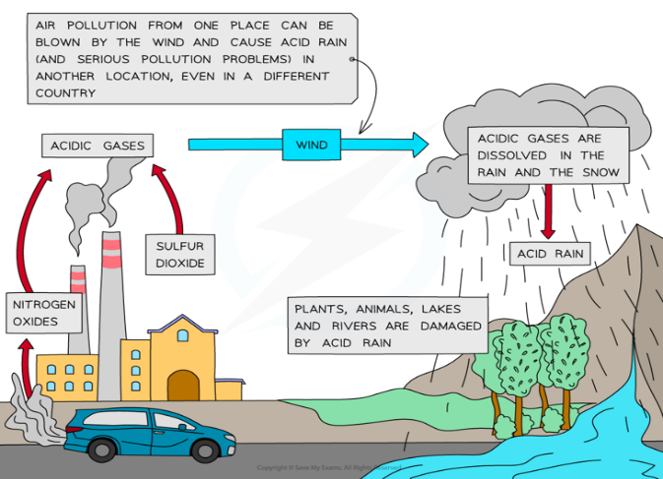

1. Outline two gases that can cause air pollution (2 marks)

……………………………………………………………………………………………………………………………………………………………………………………………………………………………………………………………………………………………………………………………………

1. State two effects of acid rain in your community. (2 marks)

……………………………………………………………………………………………………………………………………………………………………………………………………………………………………………………………………………………………………………………………………

1. State two ways in which air pollution can be controlled in your community. (2 marks)

……………………………………………………………………………………………………………………………………………………………………………………………………………………………………………………………………………………………………………………………………

3. The pictures below show one of the types of rocks commonly found in Uganda. Use them to attempt the following questions.

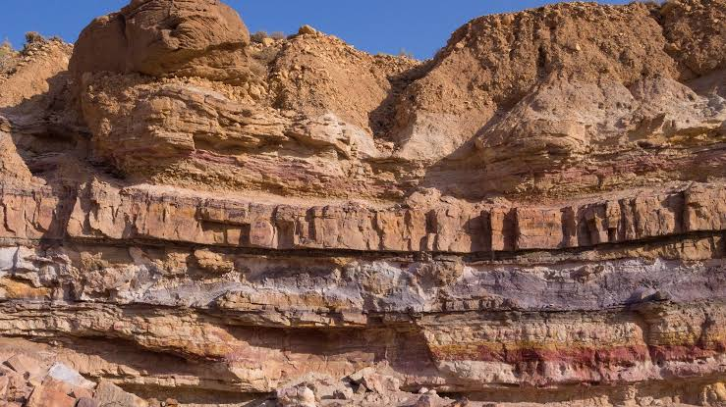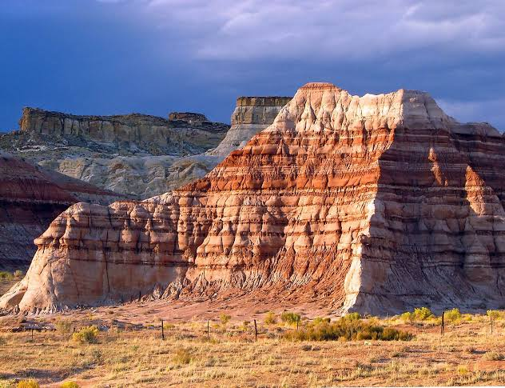

1. (i) Identify the type of rock that has been indicated in the picture above and give a reason for your answer. (02marks)

…………………………………………………………………………………………………………………………………………………………………………………………………………………………………………………………………………………………………………

(ii) Name any two examples of such type of rocks you have mentioned in a(i)above found in Uganda.(2 marks)

………………………………………………………………………………………………………………………………………………………………………………………………………………………………………………………………………………………………………..

(iii) Suggest any two characteristics of the type of rock you have named in a(i) above. (2marks)

………………………………………………………………………………………………………………………………………………………………………………………………………………………………………………………………………………………………………….

1. State any two ways how rocks are important to the people of Uganda. (2 marks)

…………………………………………………………………………………………………………………………………………………………………………………………………………………………………………………………………………………………………………

End.